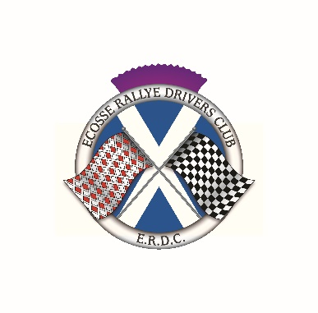

**ECOSSE RALLY DRIVERS CLUB**

**Membership** **Application**

Fill in your details and post or email this form to the address below.

Name:

Address:

Email address:

Telephone number:

I hereby apply for Membership of the above Club, and agree to be bound by its Rules, a copy of which I know I may obtain from the Club Secretary, or on the ERDC tab of the [www.monte.scot](http://www.monte.scot) website. Membership is for the calendar year and due for renewal by 30 January each year.

Signature: Date:

**Annual** **Membership** **Subscription:** **£10.00**

Please make payment by bank transfer to

Ecosse Rallye Drivers Club

Santander

Sort Code 09 01 29

Account number 38813548

When transferring funds, please use your name as the reference

or

Pay by cheque made out in favor of ‘Ecosse Rallye Drivers Club’ sent to –

June Anderson

2 Castleroy Road

Broughty Ferry

Dundee DD5 2LQ

[june.a.anderson@outlook.com](mailto:june.a.anderson@outlook.com)

Your details will be held on a data base but will not be passed on to a third party.